Terdapat problem pada sql ketika melakukan import, seperti dibawah ini

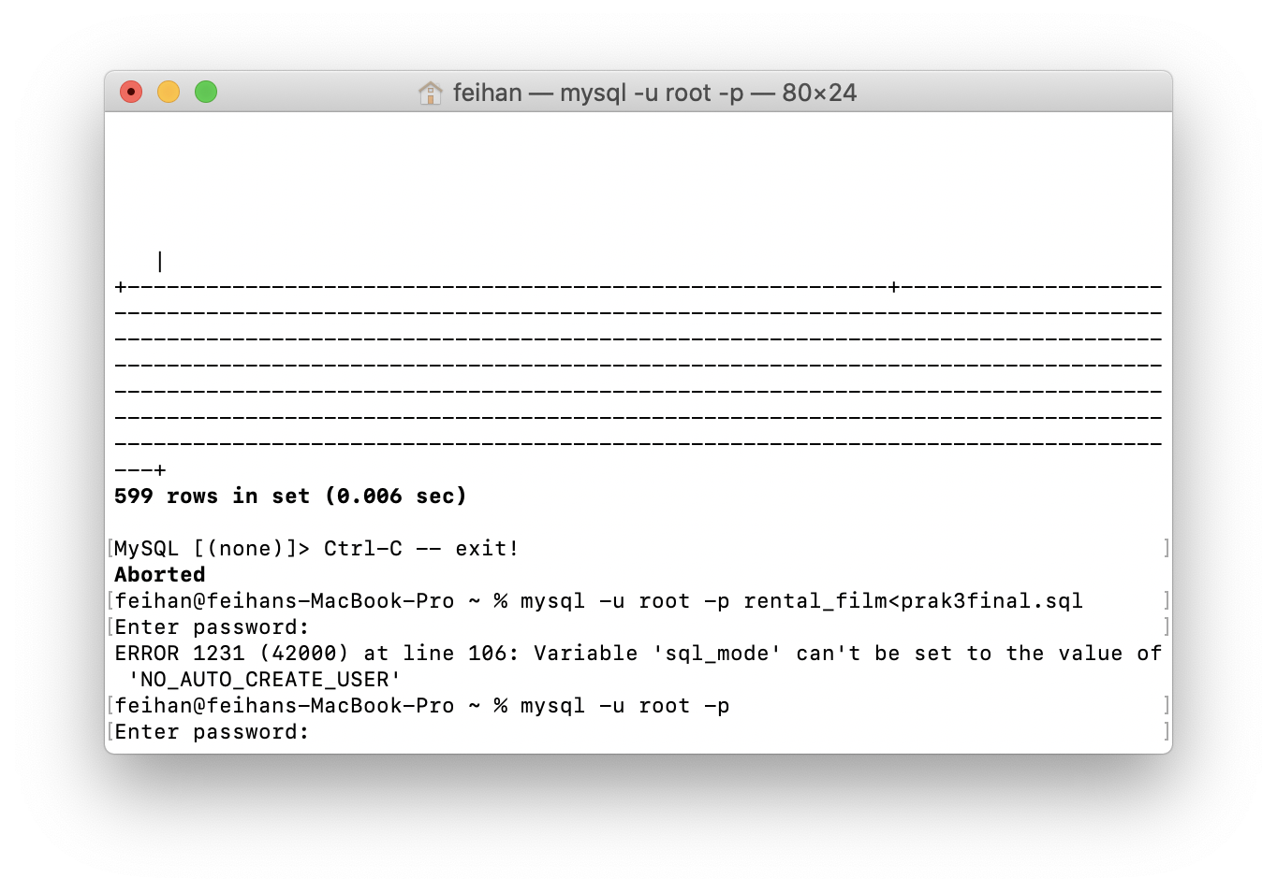

Akibatnya, hanya terdapat beberapa table yang bisa diimport pada “rental_film” dan table yang hanya bisa diimport ada pada dibawah ini

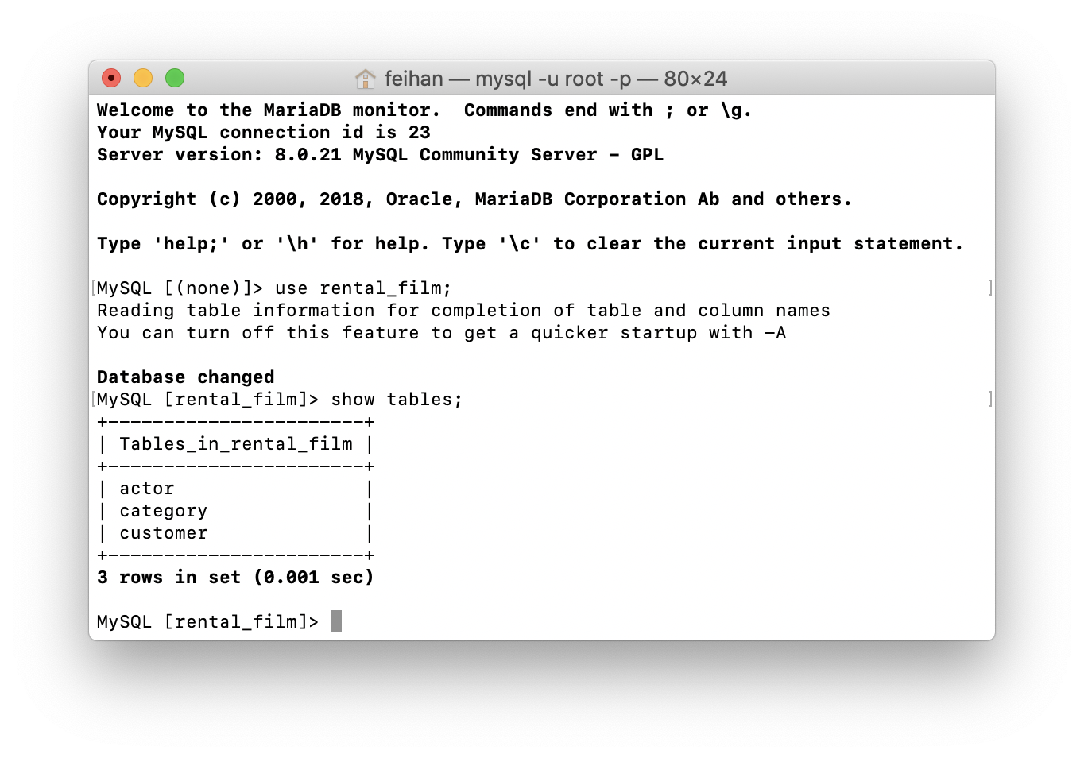

Dengan masalah tersebut, maka melakukan query menjadi tidak mungkin. Tetapi dengan mengubah sql yang ada pada soal, maka dapat dilakukan query-query dibawah ini(apabila terdapat perbedaan, ada kemungkinan karena sql soal diubah, dimana nilai “NO_AUTO_CREATE_USER” dihapus demi bisa dijalankannya soal ini)

1.select title,release_year from film limit 10 order by length desc,title asc;

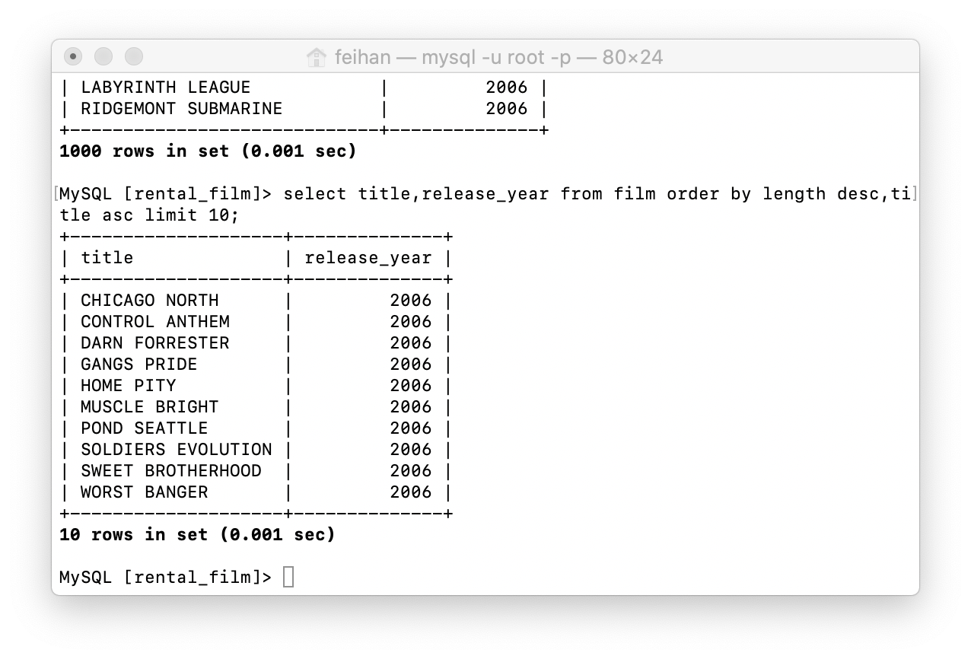

2.select staff_id,concat(first_name,last_name) from staff where staff_id in (select manager_staff_id from store);

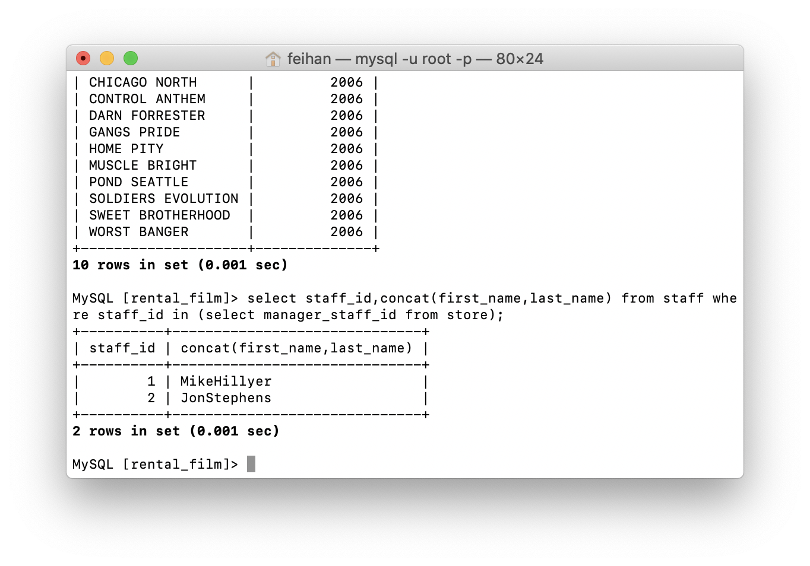

3.select store.store_id,count(inventory.film) from store join inventory on inventory.store_id=store.store_id group by store.store_id;

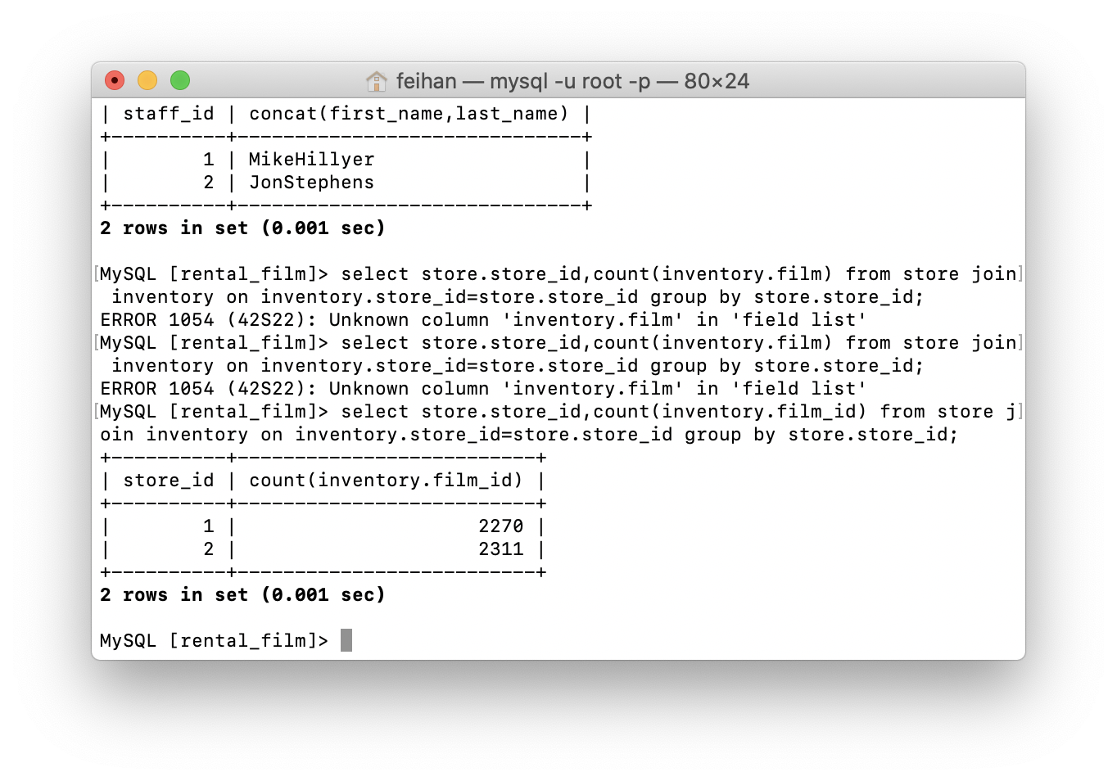

4.select concat(actor.first_name,actor.last_name) from actor natural inner join film_actor natural inner join film where film.title=“ACADEMY DINOSAUR”;

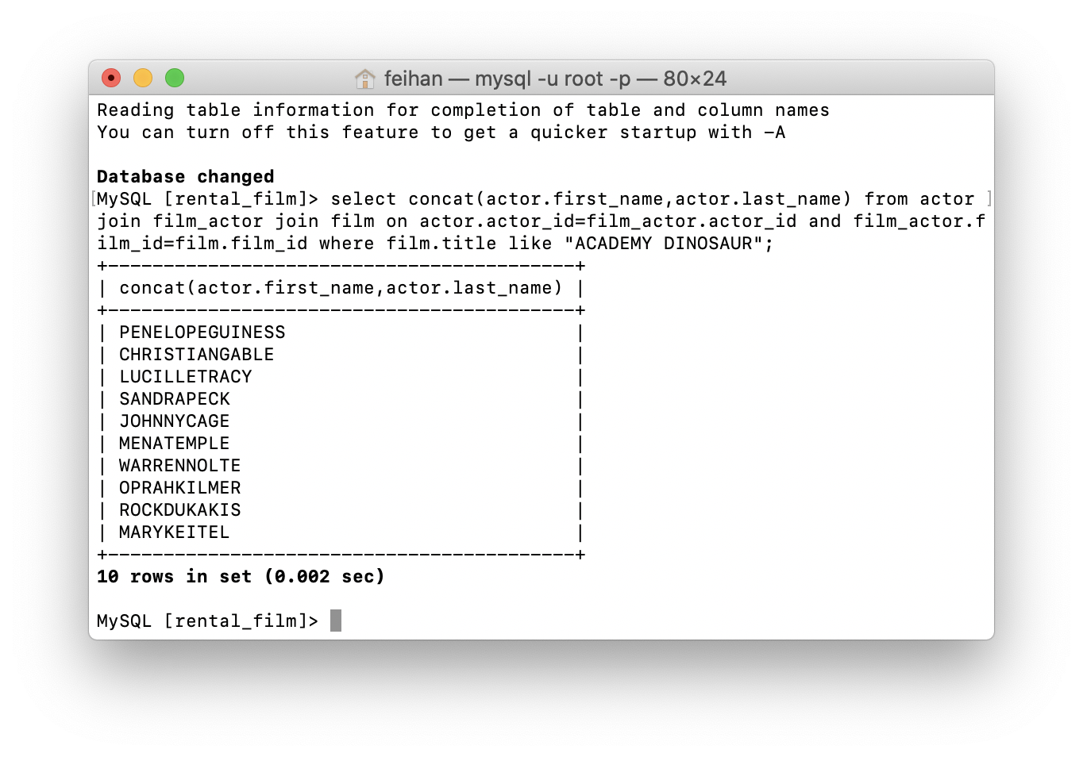

5.select film.title from film join language on film.language_id=language.language_id where language.name=“English” order by title asc;

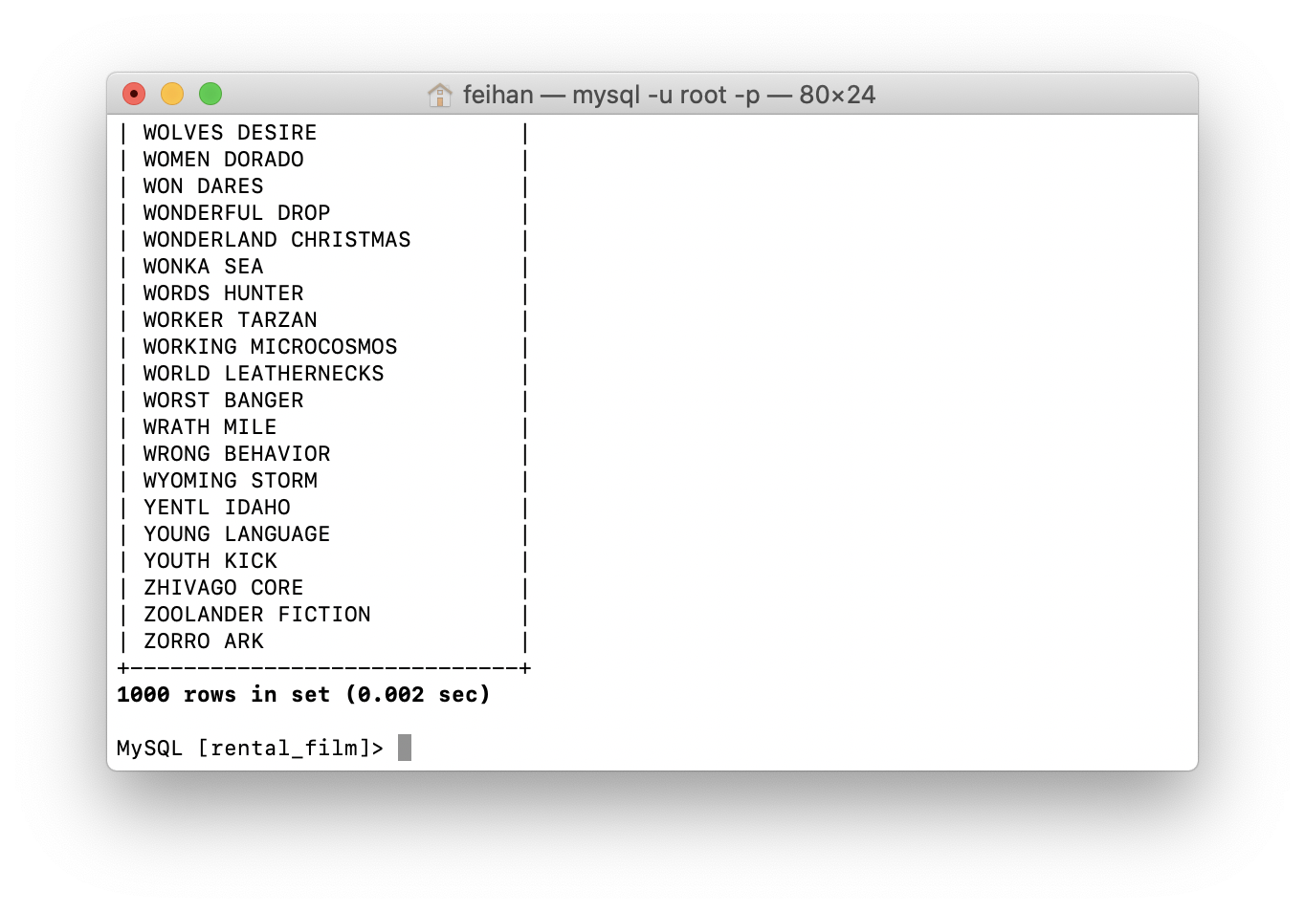

6.

7. select actor.actor_id from actor natural inner join film_actor natural inner join film_caregory natural inner join category where category.name=“Horror” or category.name=“Action”;

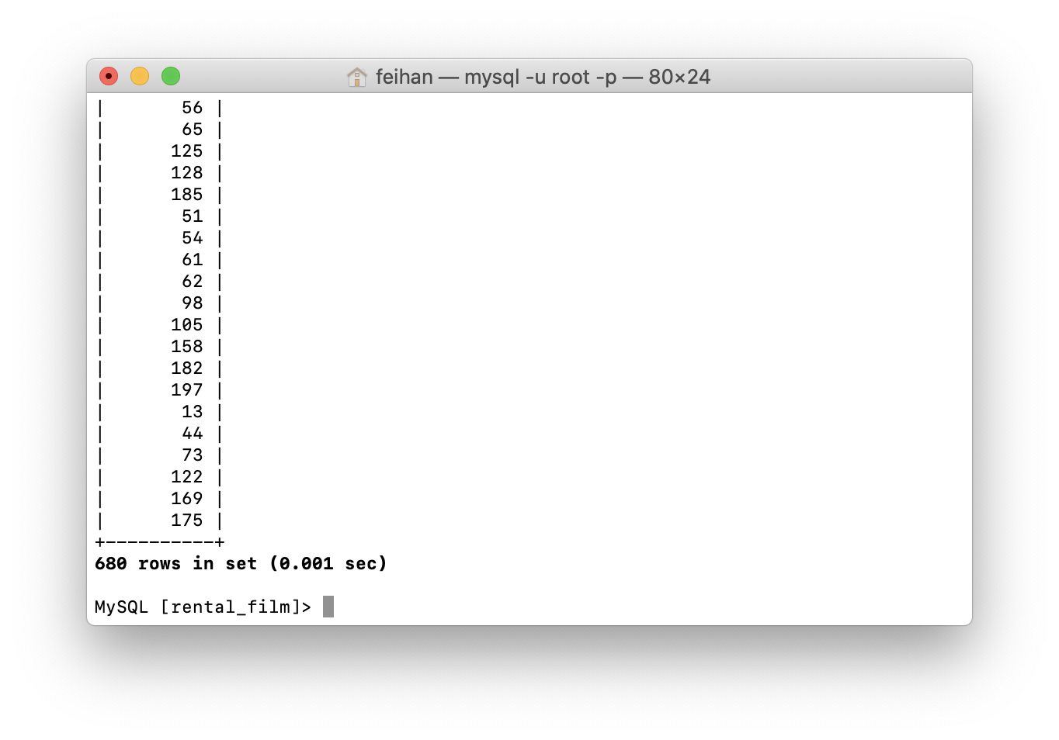

8.

9. delete from language where language_id not in (select language_id from film);

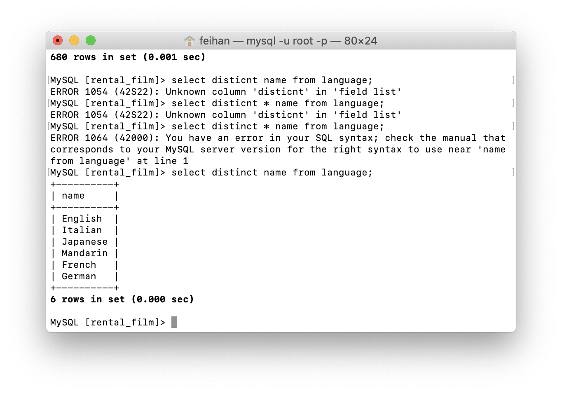

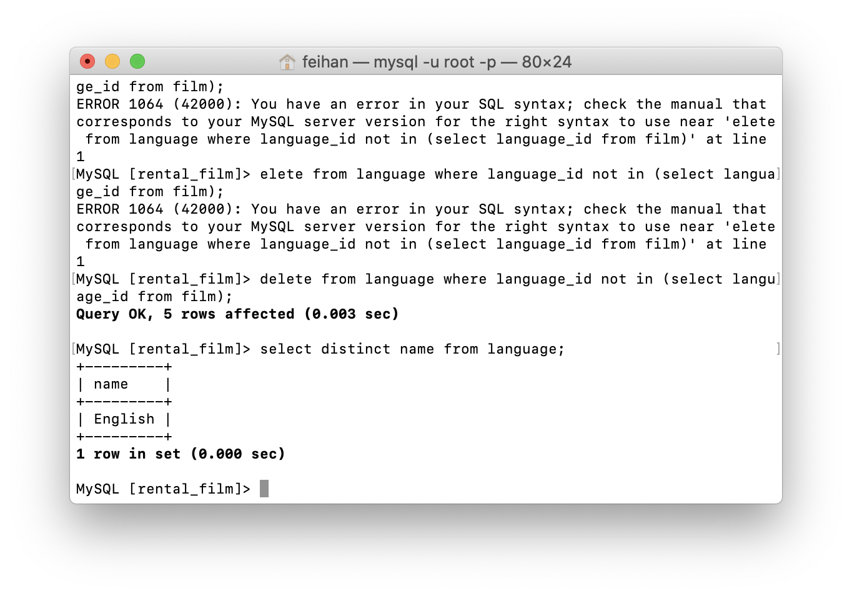

10. update film set title=replace(title,’DUCK’,’CHICKEN’) where title like ‘%DUCK%’;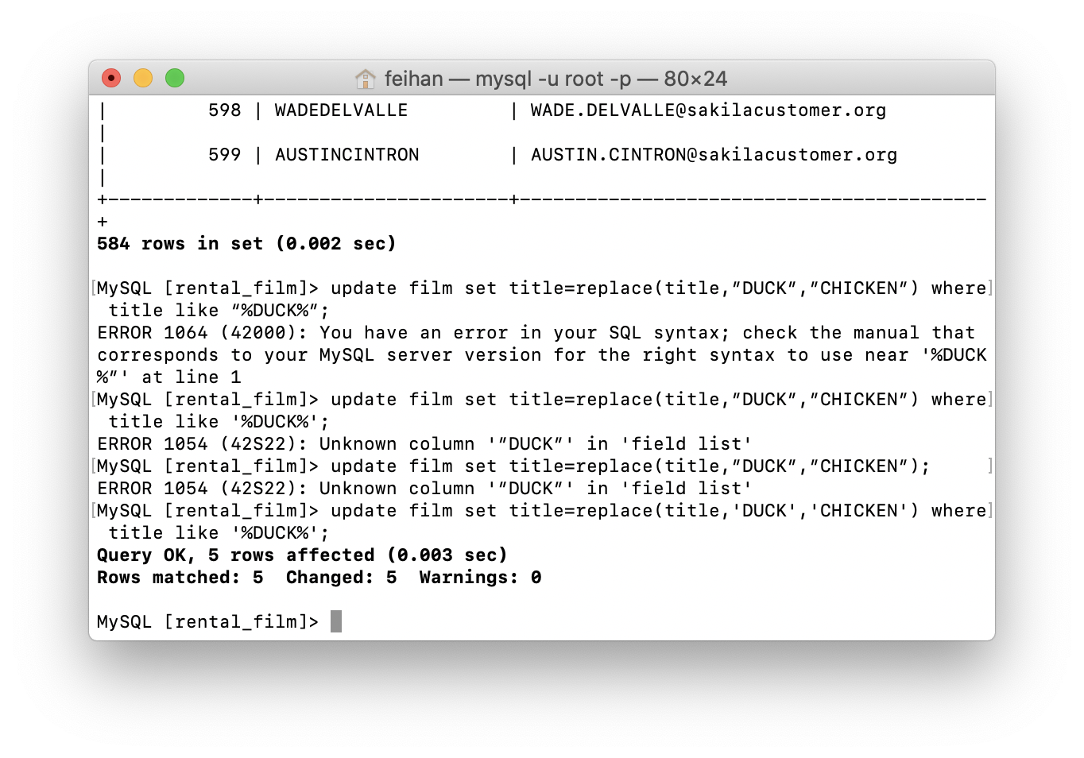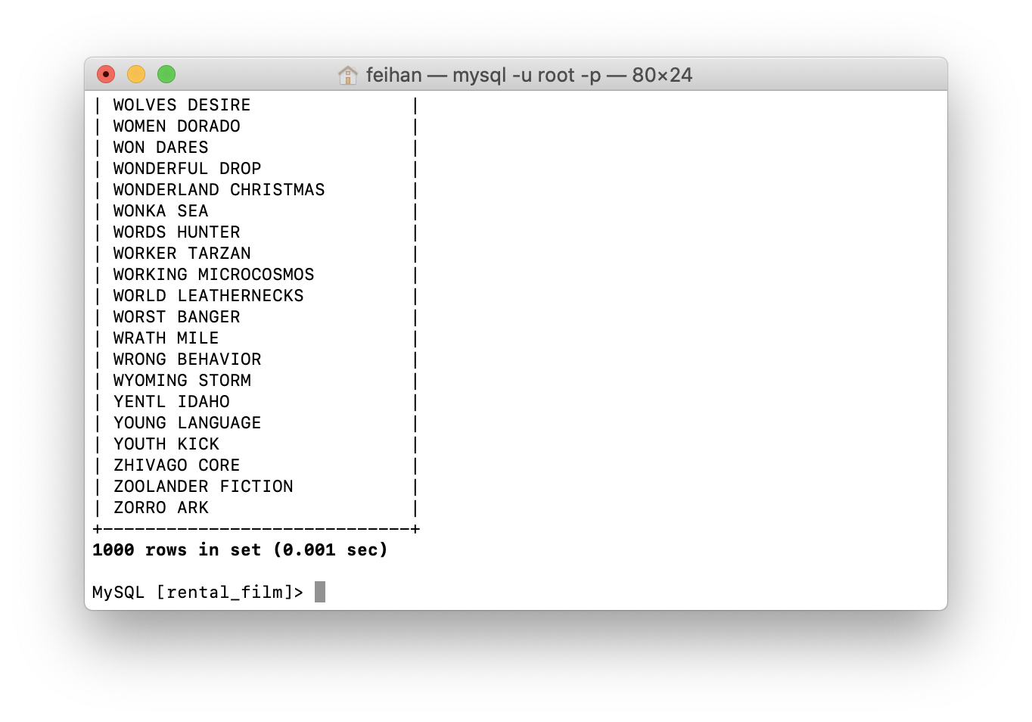



11.insert into store values(3,3);

update staff set store_id=3 where staff_id in (select staff_id from staff group by staff_id having count(active)>25);

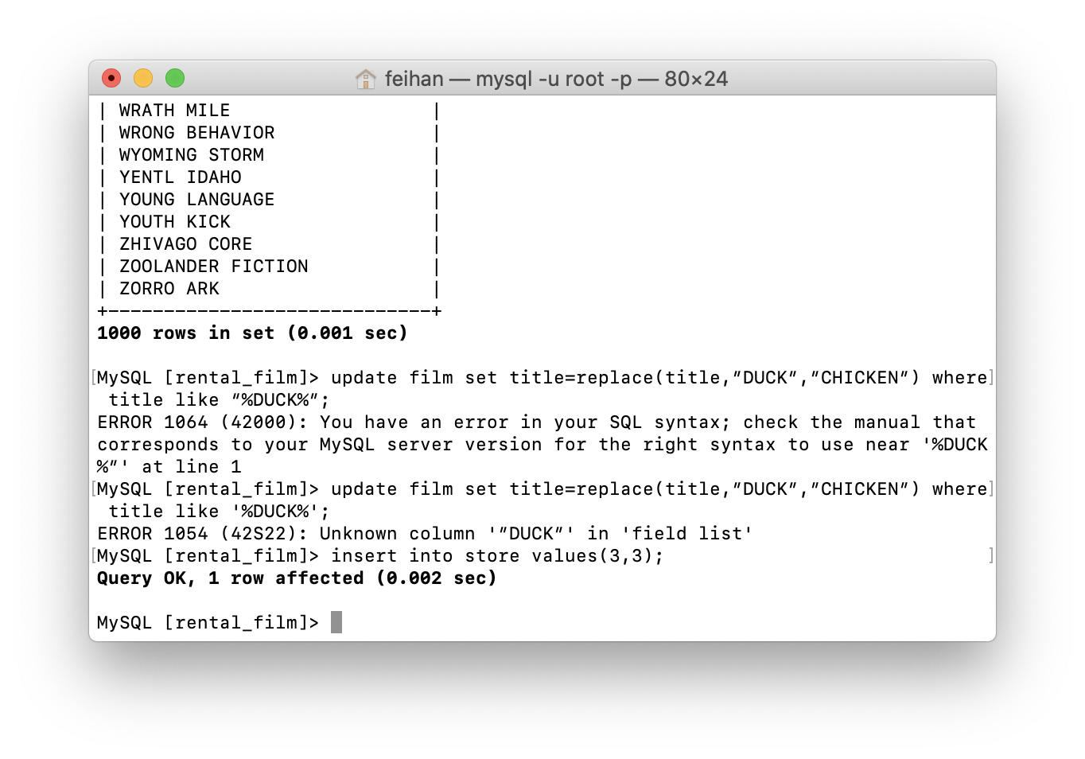

12. create view customer_account as (select customer_id,concat(first_name,last_name) customer_name,email from customer where active=1);

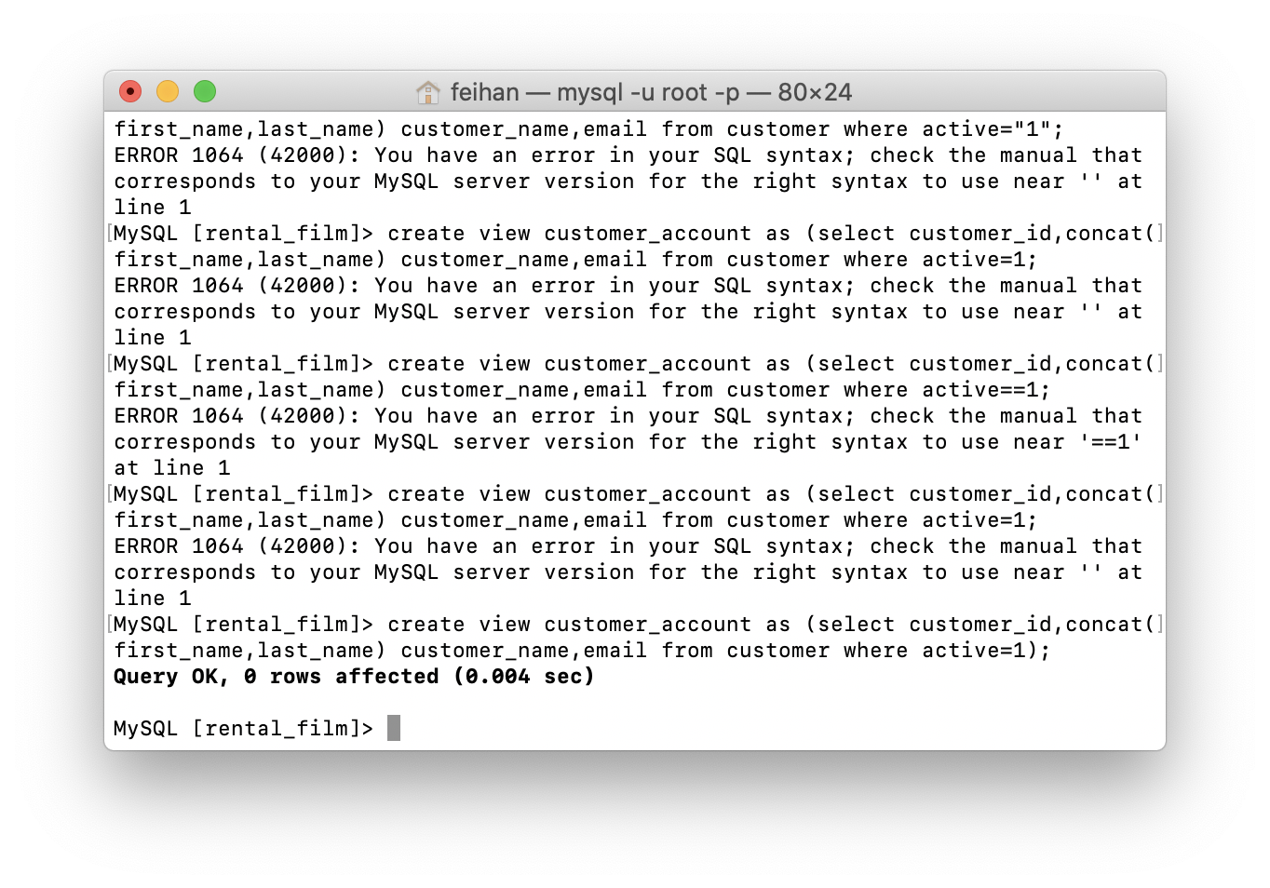

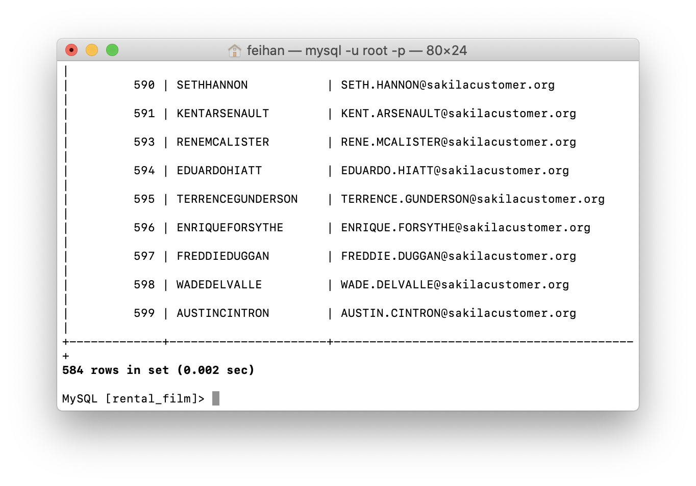

13.